# Lab 4 Report

# 1. Experimental environment Preparation

## 1.1 Enable the WSL function

Open PowerShell as an administrator and execute the following command:

**wsl --install**

The system will automatically install the default **Ubuntu** version. Restart the computer to complete the installation.

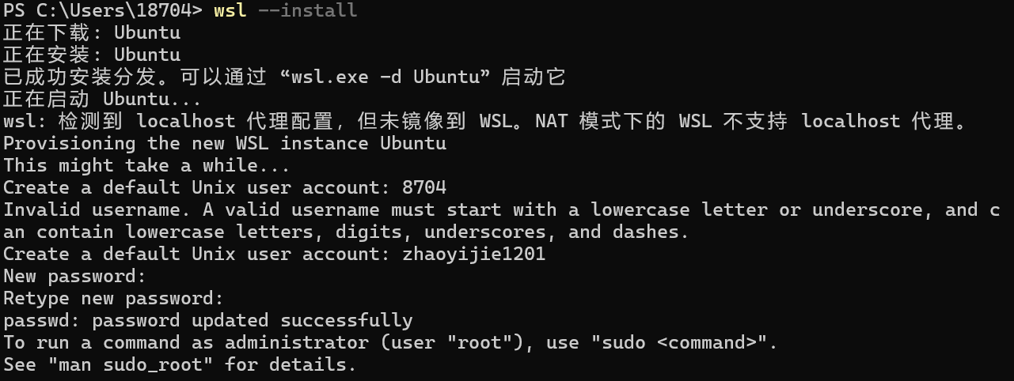

## 1.2 Install Docker Desktop

Visit the Docker website to download **Docker Desktop for Windows**, and follow the installation guide to complete the installation.

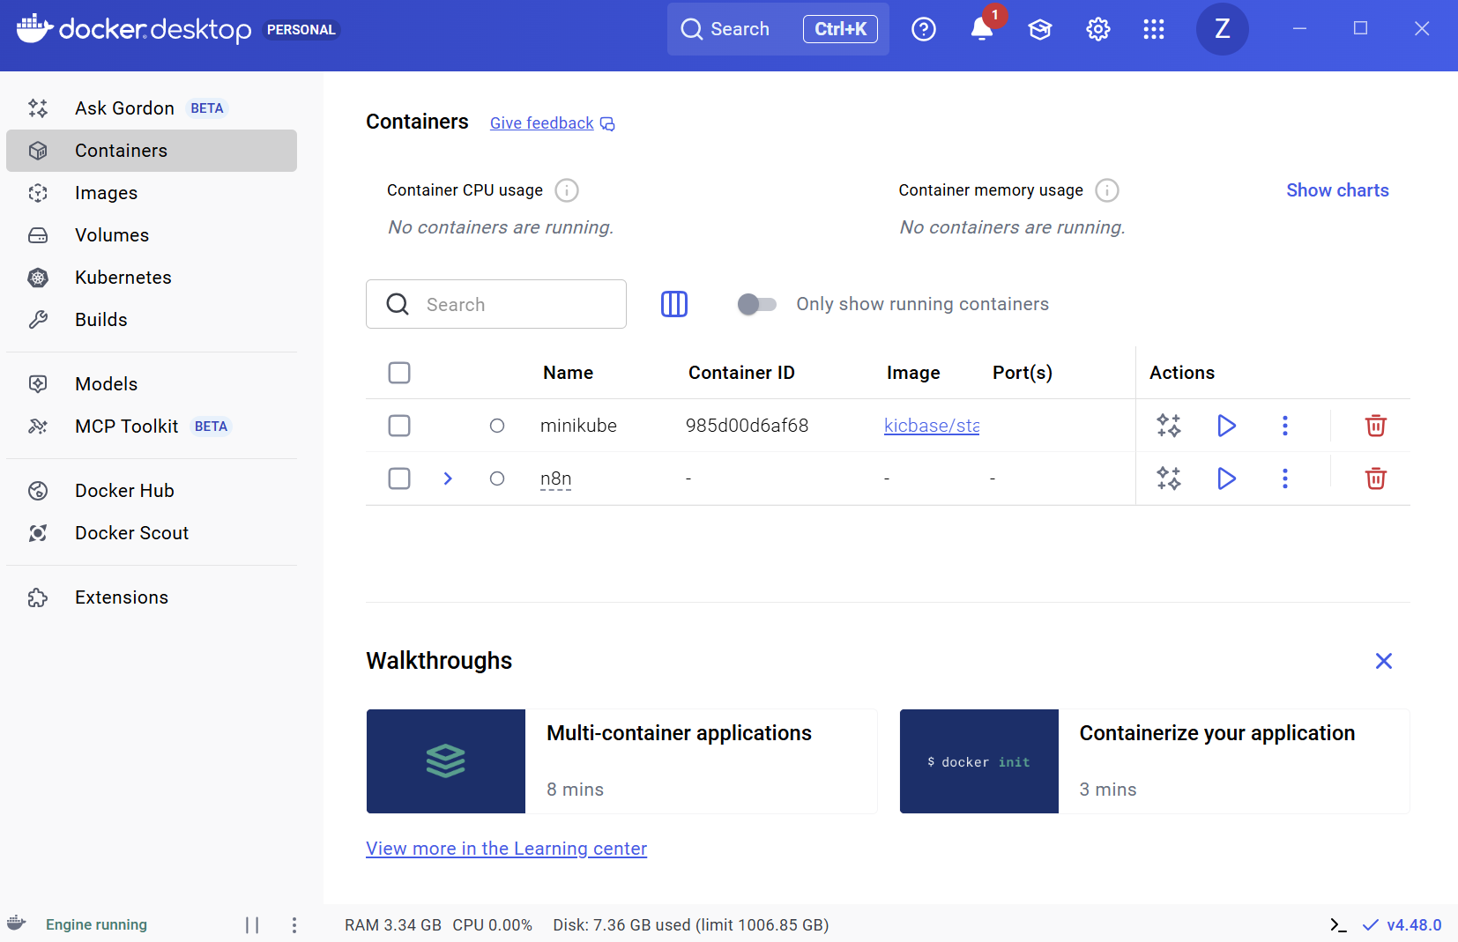

## 1.3 Verify Docker installation

Open PowerShell or Command Prompt, and run the following command to verify the installation.

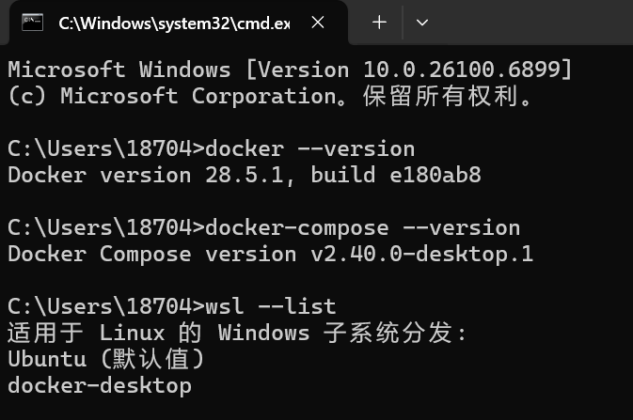

# 2. Detailed experimental procedures

## 2.1 Create the directory structure for Gitea

Create the necessary gitea directory in PowerShell, and create and edit the docker-compose.yml file.

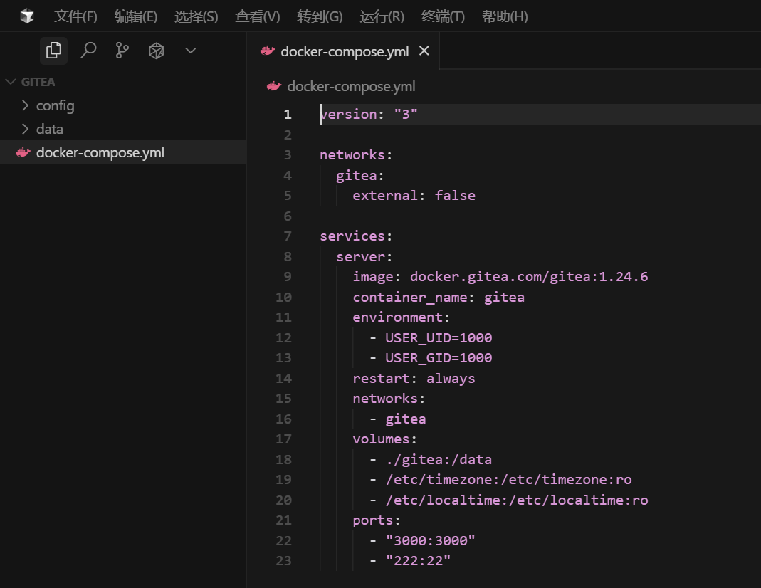

## 2.2 Start Gitea

Navigate to the Gitea directory in PowerShell and start the service.

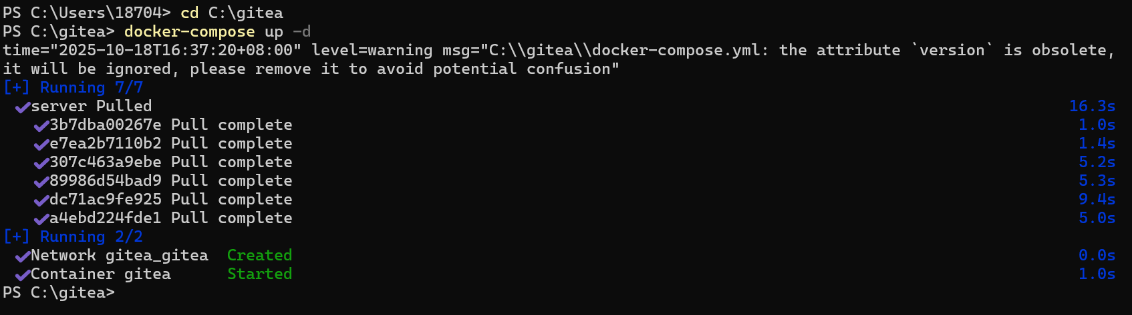

Check the status of the container.



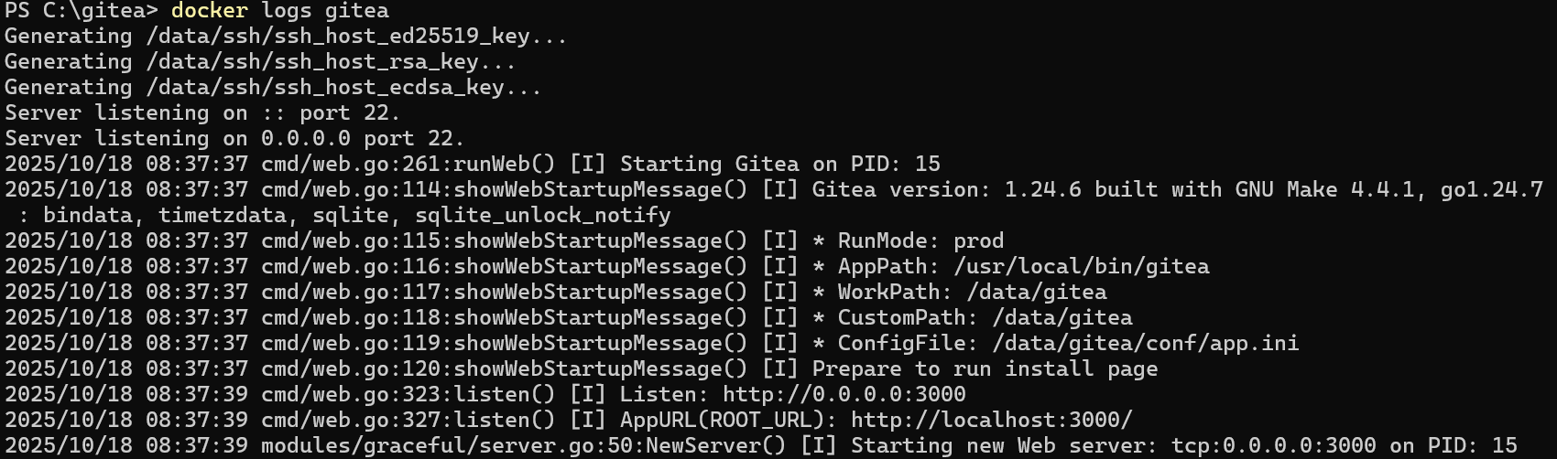

## 2.3 Access and configure Gitea

Open the browser and visit: [**http://localhost:3000**](http://localhost:3000)**,** configure according to the installation wizard.

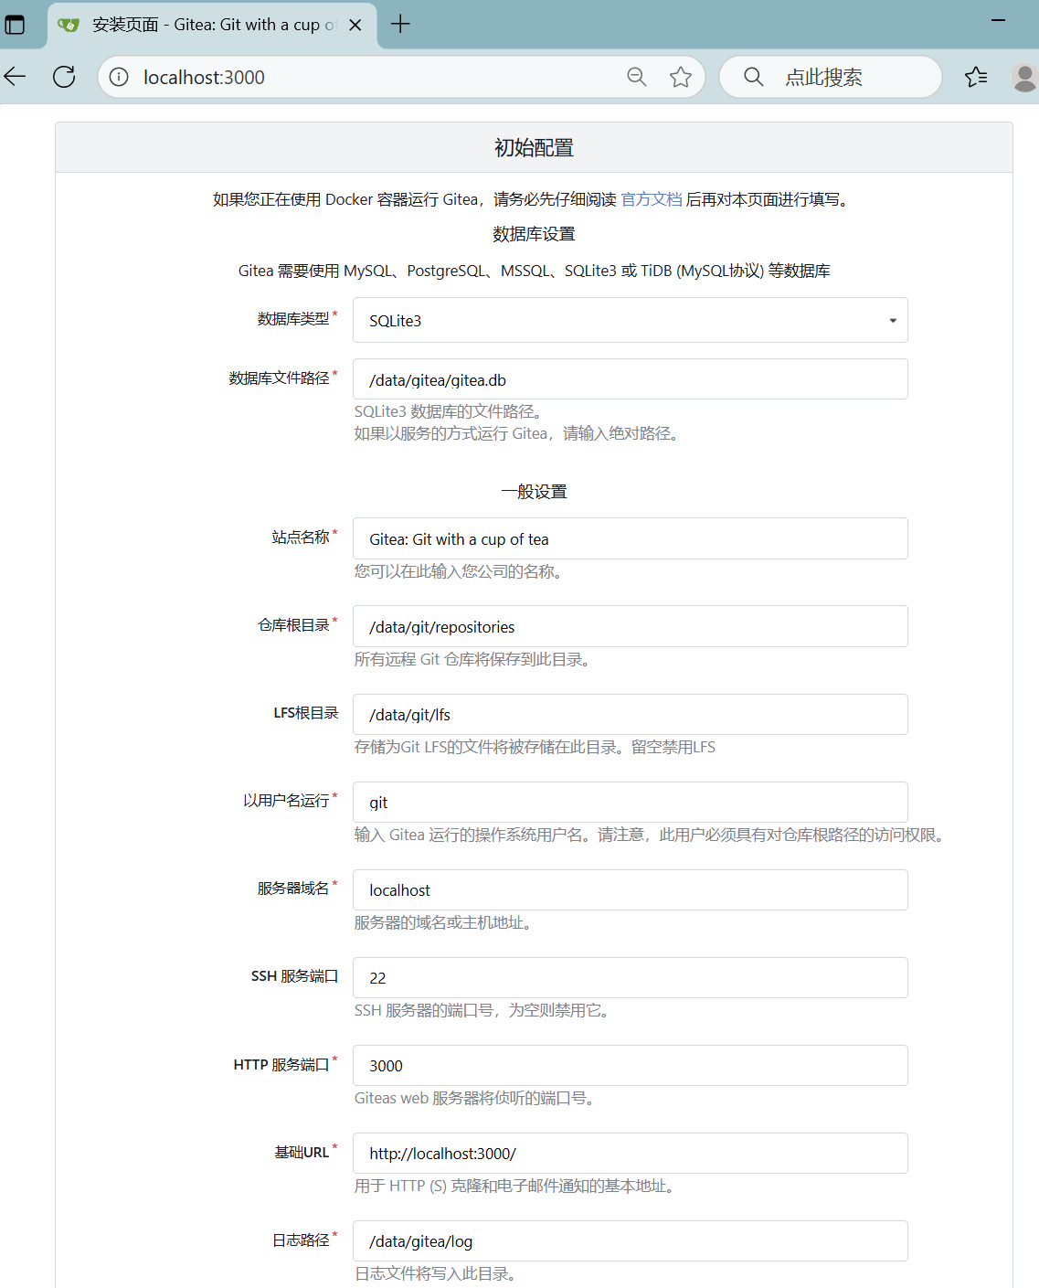

## 2.4 Configure and use Gitea LFS

1.First, make sure the Gitea instance has LFS support enabled.



2.Create a new repository on Gitea.



3.Install and configure Git LFS on Windows from [**https://git-lfs.com**](https://git-lfs.com).

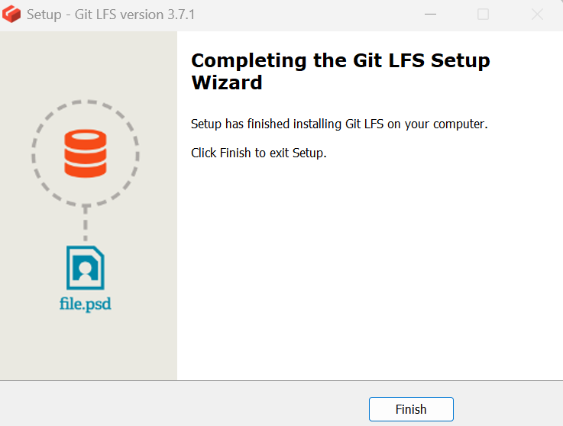



4. Clone the repository and configure LFS.

* Gitclone repository to local file

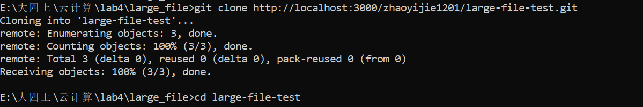

* Configuring LFS

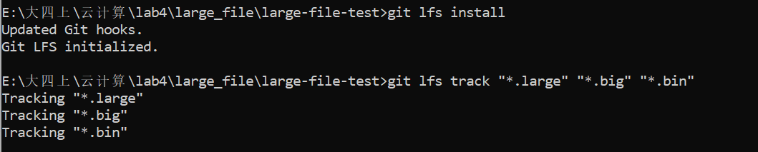

5. Commit and push large files

* Creating large files



* Add the file and commit

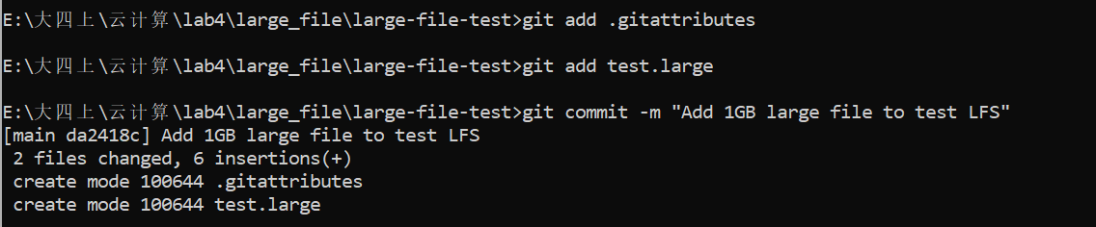

* Push to Gitea

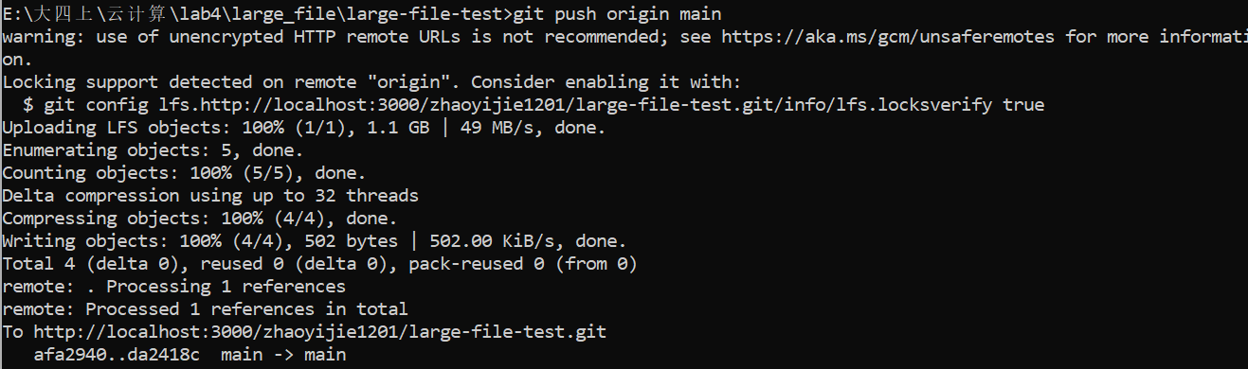

6. Verify that LFS works

The successfully pushed large files can be seen on the Gitea repository page.